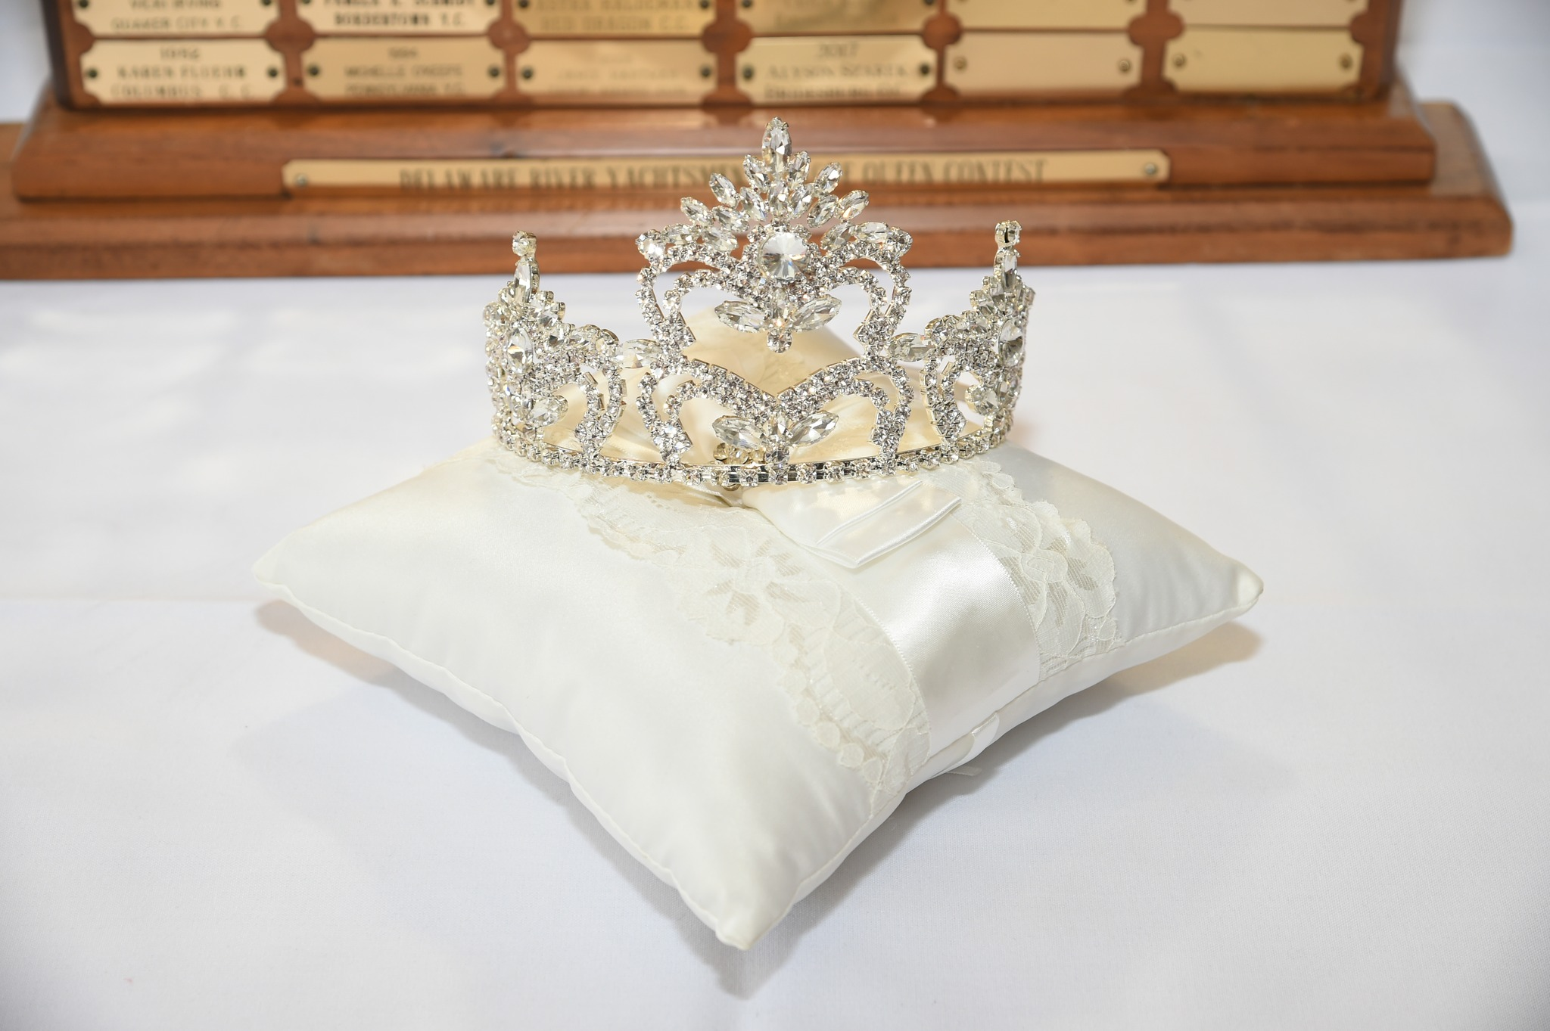
Miss DRYL Queen’s Pageant
2025 Information/Official Rules & Responsibilities

1. A complete permission form along with entry fee must be received by the first Tuesday in May at the DRYL meeting. Make all checks payable to the DRYL for $150.00.

2. Contestant must be single, never married, nor had a marriage annulled or divorced.

3. Contestant cannot have had a child or be knowingly pregnant at the time of the Pageant.

4. Only family of club members are eligible. (i.e. daughter, niece, sister, cousin, granddaughter or ward).

5. Contestant must be 15 years old by the day of preliminary judging. Contestant cannot have had her 21st birthday by the day of the Pageant.

6. Past Queens of the DRYL Queen’s Pageant cannot participate.

7. There will be no swim suit or talent competition.

8. Code of Conduct
All Contestants must be of good moral character and must not have exhibited behavior contradictory to this. No Contestant will have a criminal record or have been convicted of a crime. There also can be no criminal charges presently pending against the contestant.

Contestants will conduct themselves in a courteous, professional manner at all times. Participants are not permitted to consume alcoholic beverages while in crown and sash and must be aware that they serve as role models to the other young people of the League.

Contestant must not defame the Pageant, the DRYL Queen (past or present), any Pageant Contestant, the DRYL, the Pageant Chairperson and or Committee, through any actions at all: whether it be oral or written, including any statements or remarks on internet message boards, and sites such as Facebook, Instagram or Twitter etc. During or after the Pageant, if a contestant defames any of the above, in any way, she will be banned from participating in the Pageant and any and all future DRYL Queen’s Pageant.

The Pageant Chairperson(s) and Committee expect each Contestant to display the highest degree of sportsmanship during her reign as Princess. Each contestant should be mindful that they are representing themselves, their family, their yacht club and the DRYL. Unsportsmanlike conduct could result in the disqualification and affect future eligibility to compete in the DRYL Queen’s Pageant. Any contestant and/or family member, friend or guest, showing unsportsmanlike behavior could be disqualified and her ability to partake in future DRYL Queen’s Pageants.

9. Dress Attire
Tiara and sash with the club name must be worn during the entire day’s events at the Pageant and all other DRYL events. Tiaras should not exceed 2 inches with the exception of the Queen’s tiara. Crowns are not acceptable. Sash should be no wider than a width of 4 inches.

Preliminary Interview dress attire should be professional wear.

Evening attire for the Pageant is a long formal gown or suit/tuxedo. Contestant may select color and design of the gown.

Pageant Day Luncheon/Opening/Closing Day - attire should be appropriate dress. Dresses, suits, dress pants or capri dress pants are acceptable. Footwear selection should be appropriate to the dress attire keeping in mind that flip flops and sneakers are unacceptable. Please keep in mind that footwear selection should be appropriate for walking on floating docks.

DRYL Banquet attire should be evening dress, formal pantsuit, or suit/tuxedo. Dress may be long or short.

10. Judging & Scoring:
Judges can not be members of any yacht club affiliated with the DRYL nor can they be related in any way to a contestant or a member of a yacht club.

Contestant understands that judging will consist of:
a) 50% Pageant Interviews
b) 40% Evening Pageant Questions
c) 10% DRYL/Club Activities

Judging will be done on a point system based on: poise, personality, appearance, friendliness, enthusiasm, delivery of response, and application presentation.

Activity Book – Each contestant will receive a book to record each approved boat club or league event she may attend. The book is to be signed by the Commodore of the club she is visiting along with the signature of a Pageant Committee prior to leaving an event. Each contestant will receive credit for up to 17 events plus receive additional credit for 2 mandatory Pageant meetings scheduled by the Pageant Committee. It is not required to attend 19 events.

Contestant must attend the Preliminary Interview and Pageant as a part of the judging. If not in attendance, contestant will be disqualified from any further activities or judging.

Decision of the judges will be final and all scores will be kept confidential.

11. Awards
Judges will choose:
2nd runner up – recipient will receive trophy and flowers
1st runner up - recipient will receive trophy and flowers
Queen - recipient will receive rotating trophy, personal trophy, crown, sash, Queen’s flag, carrying case for crown and flowers

Contestants will choose The Candyce Holmstrup Award recipient (formerly Miss Congeniality) during the afternoon luncheon on Pageant day by secret ballot.

The Candyce Holmstrup Award recipient will receive trophy and flowers

12. Requirements for the Queen
Contestant understands and agrees that if selected Miss DRYL Queen she will be required to attend and assist with certain functions and activities throughout her reign such as but not limited to:

a) DRYL Von Nieda Picnic
b) DRYL Banquet
c) Pageant Meetings
d) YCM & CBYCA Events (Queen of the Chesapeake Pageant, CBYCA Ball)
e) DRYL Meetings
f) DRYL clubs opening/closing days

The Queen should attend all major DRYL events unless previously excused by the Queen’s Pageant Committee due to illness, mandatory school function or mandatory employment conflict.

In the event the DRYL Queen changes her marital status prior to the date of the next contest, she has the option to remain as Queen or relinquish her title. If she chooses to relinquish her title, the 1st runner up will reign as the DRYL Queen for the remainder of the year.

If Miss DRYL Queen becomes pregnant anytime during her reign, she has the option to remain as Queen or relinquish her title. If she chooses to relinquish her title, the 1st runner up will reign as the DRYL Queen for the remainder of the year.

The Queen must wear her crown and sash to all DRYL functions, and act according to the code of conduct.

If the DRYL Queen does not comply with the rules, she shall automatically be disqualified. She will then relinquish her title and the 1st runner up shall reign as the DRYL Queen for the remainder of the year.

In the event the 1st Runner up is not qualified, the 2nd runner up shall reign.

Reigning Queen will participate in the crowning of the newly elected Queen.

13. In the future, should the need for something to be added to these Rules & Responsibilities, The Queen’s Pageant Committee will make the needed changes.

Revised Official Rules & Responsibilities, February 2025.

